Bahria University,

Karachi Campus



COURSE: CSC-110 COMPUTING FUNDAMENTALS

TERM: FALL 2020, CLASS: BSE- 1 (B)

Submitted By:

M MUAZ SHAHZAD 02-131202-081

(Name) (Reg. No.)

Submitted To:

Dr. Salahuddin / Engr. Saniya Sarim

Signed Remarks: Score:

INDEX

|  |  |  |  |  |
| --- | --- | --- | --- | --- |
| SNO | DATE | LAB NO | LAB OBJECTIVE | SIGN |
| 01 | 29-OCT-2020 | 06 | INTRODUCTION TO HTML II |  |
|  |  |  |  |  |
|  |  |  |  |  |
|  |  |  |  |  |
|  |  |  |  |  |
|  |  |  |  |  |
|  |  |  |  |  |
|  |  |  |  |  |
|  |  |  |  |  |
|  |  |  |  |  |
|  |  |  |  |  |
|  |  |  |  |  |
|  |  |  |  |  |
|  |  |  |  |  |
| SNO | DATE | LAB NO | LAB OBJECTIVE | SIGN |
|  |  |  |  |  |
|  |  |  |  |  |
|  |  |  |  |  |
|  |  |  |  |  |
|  |  |  |  |  |
|  |  |  |  |  |
|  |  |  |  |  |
|  |  |  |  |  |
|  |  |  |  |  |
|  |  |  |  |  |
|  |  |  |  |  |
|  |  |  |  |  |
|  |  |  |  |  |
|  |  |  |  |  |
|  |  |  |  |  |

Bahria University,

Karachi Campus



LAB EXPERIMENT NO.

**06**

LIST OF TASKS

|  |  |
| --- | --- |
| TASK NO | OBJECTIVE |
| 1 | Create a webpage on any topic. It should include headings, images, paragraphs, links, lists and tables of any type |
| 2 | Create a marksheet in HTML |
|  |  |
|  |  |
|  |  |
|  |  |
|  |  |

Submitted On:

Date: 04/11/2020

**Task No. 1: Create a webpage on any topic. It should include headings, images, paragraphs, links, lists and tables of any type**

**Solution:**

<!DOCTYPE html>

<html>

<head>

<title>Web Page</title>

</head>

<body bgcolor="lightblue">

<center><h1 style= "font-size: 250%;font-family: TimesNewRoman;color: darkblue;">PAKISTAN NAVY</h1></center>

<img style="background-color:"lightblue src="C:\Users\Muaaz Shahzad\Downloads\images (1).jpg" width="100" height="60">

<p style="font-size: 120%;font-family: Arial;">The <b>Pakistan Navy</b> is the naval warfare branch of the Pakistan Armed Forces. It came into existence by transfer of personnel and equipment from the Royal Indian Navy that ceased to exist following the partition of British India through a parliamentary act that established the independence of <b>Pakistan</b> and India from the United Kingdom on 14 August 1947.Its primary objective is to ensure the defence of the sea lines of communication of Pakistan and safeguarding Pakistan's maritime interests by executing national policies through the exercise of military effect, diplomatic and humanitarian activities in support of these objectives.In addition to its war services, the Navy has mobilized its war assets to conduct humanitarian rescue operations at home as well as participating in multinational task forces mandated by the United Nations to prevent seaborne terrorism and privacy off the coasts.The Pakistan Navy is a volunteer force which has been in conflict with neighbouring India twice on its sea borders, and has been repeatedly deployed in the Indian Ocean to act as a military advisor to Gulf Arab states and other friendly nations during the events of multinational conflict as part of its commitment to the United Nations.The Navy has several components including the <b>Naval Aviation, Marines, and the Maritime Security Agency (a coast guard).</b>Since its commencement on 14 August 1947, the defensive role of the Navy has expanded from securing the sealines and becoming the custodian of Pakistan's second strike capability with an ability to launch underwater missile system to target enemy positions.The Navy is commanded by the Chief of Naval Staff, a four-star admiral, who is a member of the Joint Chiefs of Staff Committee.<b>The Chief of Naval Staff</b> is nominated by the <b>Prime Minister</b> and appointed by the <b>President of Pakistan.</b> <b>The current Chief is Admiral Amjad Khan Niazi who was appointed on 7 October 2020.Admiral Amjad is a 22nd Chief of the Pakistan Navy who takes the charge after Zafar Mahmood Abbasi.</b></p>

<a href="https://www.paknavy.gov.pk/"><center><img src="C:\Users\Muaaz Shahzad\Downloads\navy admiral.jpg" width="550" height="450">For More Details Click On Image

</center></a>

<h1 style="font-family: TimesNewRoman;font-size: 150%;color: darkblue;"> RANKS OF PAK NAVY'S OFFICERS</h1>

<ul>

<li style="font-size: 110%;">MIDSHIPMAN</li>

<li style="font-size: 110%;">SUB LIEUTENANT (S/Lt)</li>

<li style="font-size: 110%;">LIEUTENANT (Lt) </li>

<li style="font-size: 110%;">LIEUTENANT COMMANDER (Lt Cdr)</li>

<li style="font-size: 110%;">COMMANDER (Cdr)</li>

<li style="font-size: 110%;">CAPTAIN (Capt)</li>

<li style="font-size: 110%;">COMMODORE (Cdre)</li>

<li style="font-size: 110%;">REAR ADMIRAL (RAdm)</li>

<li style="font-size: 110%;">VICE ADMIRAL (VAdm)</li>

<li style="font-size: 110%;">ADMIRAL (Adm)</li><br>

<h1 style="font-family: TimesNewRoman;font-size: 150%;color: darkblue;position: left">SHIPS OF PAK NAVY</h1>

<table border="1" cellspacing="0">

<tr>

<th colspan="4" style="font-size: 150%;color: darkslategray;font-family: TimesNewRoman">Class</th>

<th colspan="3" style="font-size: 150%;color: darkslategray;font-family: TimesNewRoman">Type</th>

<th colspan="4" style="font-size: 150%;color: darkslategray ;font-family: TimesNewRoman">Origin</th>

<th colspan="3" style="font-size: 150%;color: darkslategray;font-family: TimesNewRoman">Ship</th>

<th colspan="4" style="font-size: 150%;color: darkslategray;font-family: TimesNewRoman">Dispalcement</th>

<th colspan="4" style="font-size: 150%;color: darkslategray;font-family: TimesNewRoman">Picture</th>

<tr>

<td colspan="4" style="font-family: arial">Azmat class</td>

<td colspan="3" style="font-family: arial">Fast Attack Craft,Missile boat</td>

<td colspan="4" style="font-family: arial">Pakistan,China</td>

<td colspan="3" style="font-family: arial">PNS Azmat</td>

<td colspan="4" style="font-family: arial;text-align: center;">560 tons</td>

<td> <img src="C:\Users\Muaaz Shahzad\Downloads\azmat.JPG"width="307" height="150"> </td>

</tr>

<tr>

<td colspan="4" style="font-family: arial">Jurrat Class</td>

<td colspan="3" style="font-family: arial">Missile Boat</td>

<td colspan="4" style="font-family: arial">Pakistan,Germany</td>

<td colspan="3" style="font-family: arial">PNS Jurrat,PNS Quwwat</td>

<td colspan="4" style="font-family: arial;text-align: center;">250 tons</td>

<td> <img src=" C:\Users\Muaaz Shahzad\Downloads\200px-Jurrat.jpg" width="307" height="150"></td>

</tr>

<tr>

<td colspan="4" style="font-family: arial">Alamgir Class</td>

<td colspan="3" style="font-family: arial">Multi-Role guided Missile </td>

<td colspan="4" style="font-family: arial">United States</td>

<td colspan="3" style="font-family: arial">PNS Alamgir (F-260)</td>

<td colspan="4" style="font-family: arial;text-align: center;">4200 tons</td>

<td><img src="C:\Users\Muaaz Shahzad\Downloads\alamgir.jpg"width="307 " height="150"></td>

</tr>

<tr>

<td colspan="4" style="font-family: arial">Zulfiquar Class</td>

<td colspan="3" style="font-family: arial">Multi-Role guided Missile</td>

<td colspan="4" style="font-family: arial">China Pakistan</td>

<td colspan="3" style="font-family: arial">PNS Zulfiquar,PNS Aslat,PNS Shamsheer,PNS Saif </td>

<td colspan="4" style="font-family: arial;text-align: center;">4200 tons</td>

<td><img src="C:\Users\Muaaz Shahzad\Downloads\200px-PNS_Saif_-_Side_View.jpg"width="307" height="150"></td>

</tr>

<tr>

<td colspan="4" style="font-family: arial">Larkana Class</td>

<td colspan="3" style="font-family: arial">Missile Boat</td>

<td colspan="4" style="font-family: arial">Pakistan</td>

<td colspan="3" style="font-family: arial">PNS Larkana</td>

<td colspan="4" style="font-family: arial;text-align: center;">180 tons</td>

<td><img src="C:\Users\Muaaz Shahzad\Downloads\200px-Larkana_(PB_157)-090309-N-4774B-055.jpg"width="307" height="150"></td>

</tr>

</table>

<center><h1 style="font-size: 150%;font-family: TimesNeewRoman;"> "SUFFICIENT FOR US IN ALLAH,AND[HE IS] THE BEST DISPOSER OF AFFAIRS."</h1></center>

</body>

</html>

**Output:**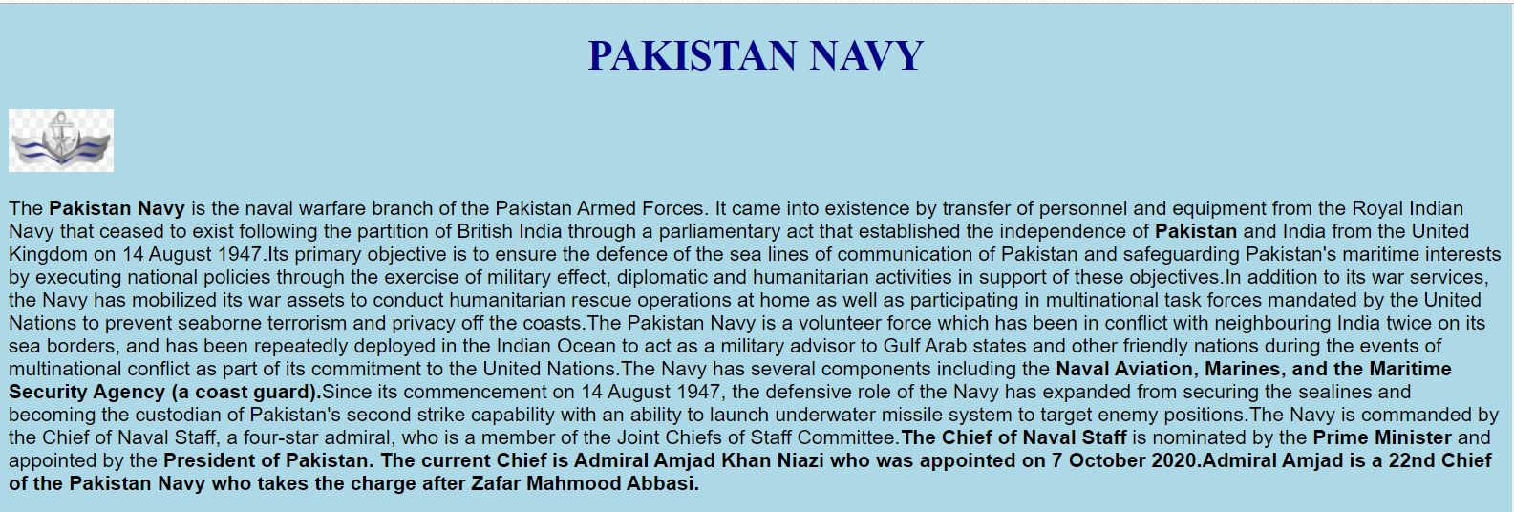

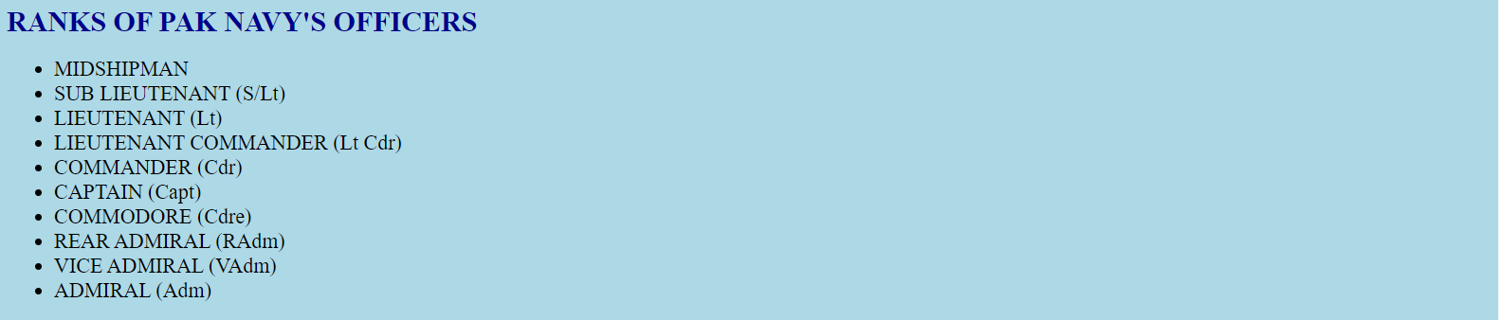

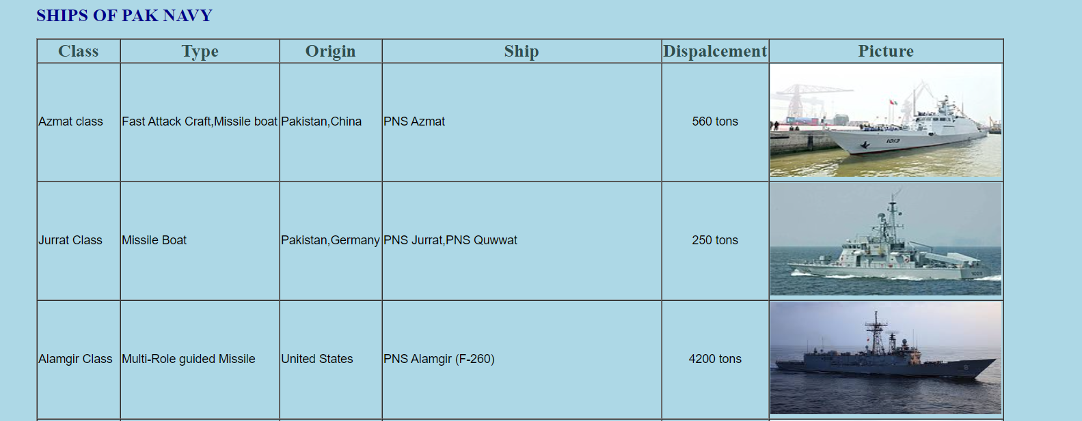

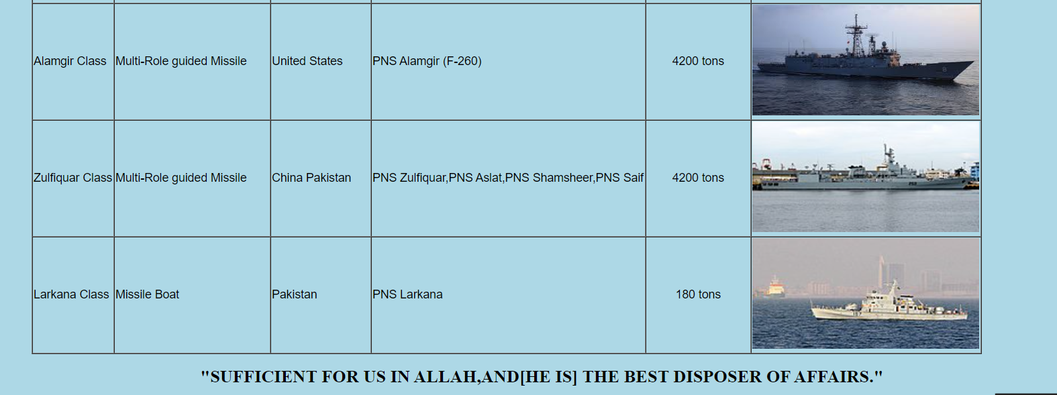

**Task No. 2:** **Create a marksheet in HTML  
  
Solution:**<!DOCTYPE html>

<html>

<head>

<title>Mark Sheet</title>

</head>

<body bgcolor="lightyellow">

<table>

<tr><th style="font-size: 170%;font-family: Times New Roman;text-align: center;">BOARD OF INTERMEDIATE EDUCATION KARACHI</th></tr>

<tr><th style="font-size: 110%;font-family: Times New Roman;text-align: center;">H.S.C PART-1 (INTERMEDIATE EXAMINATION (ANNUAL-2019)</th></tr>

<tr><th style="font-size: 150%;font-family: calibri;text-align: center;"><u><br>Statement of Marks</u></th></tr></table>

</body>

<body>

<table>

<tr>

<td style="font-family: calibri;text-align: left;"><b> Marks Sheet No:</td>

<td style="font-family: calibri;text-align: left;">00140708-2</td></b></tr>

<tr>

<td style="font-family: calibri;text-align: left;"><b>Group:</td>

<td style="font-family: calibri;text-align: left;">PRE-ENGINEERING</td></b></tr>

<tr>

<td style="font-family: calibri;text-align: left;"><b>Roll No:</td>

<td style="font-family: calibri;text-align: left;">134222</td></b></tr>

<tr>

<td style="font-family: calibri;text-align: left;"><b>Enrollment No:</td>

<td style="font-family: calibri;text-align: left;">APCS/SE/E-0027/2019</td></b></tr>

<tr>

<td style="font-family: calibri;text-align: left;"><b>Name:</td>

<td style="font-family: calibri;text-align: left;">MUHAMMAD MUAZ SHAHZAD</td></b></tr>

<tr>

<td style="font-family: calibri;text-align: left;"><b>Father's Name:</td>

<td style="font-family: calibri;text-align: left;">MUHAMMAD SHAHZAD</td></b></tr>

<tr>

<td style="font-family: calibri;text-align: left;"><b>College:</td>

<td style="font-family: calibri;text-align: left;">Army Public College,Saddar</td></b></tr>

</table></body><br><br>

<body>

<table border="1" cellspacing="0">

<thead>

<tr>

<th rowspan="2" style="font-family: Calibri">Subject</th>

<th colspan="2" style="font-family: Calibri">Max Marks</th>

<th colspan="2" style="font-family: Calibri">Obtained Marks</th>

<th rowspan="2" style="font-family: Calibri">Percentage</th>

<th rowspan="2" style="font-family: Calibri">Remarks</th>

</tr>

<tr>

<th style="font-family: calibri">Theory</th>

<th style="font-family: calibri">Practical</th>

<th style="font-family: calibri">Theory</th>

<th style="font-family: calibri">Practical</th></tr></thead>

<tr>

<td style="font-family: Calibri;">URDU NORMAL</td>

<td style="font-family: Calibri;text-align: center;">100</td>

<td style="font-family: Calibri;text-align: center;">-</td>

<td style="font-family: Calibri;text-align: center;">60</td>

<td style="font-family: Calibri;text-align: center;">-</td>

<td style="font-family: Calibri;text-align: center;">60</td>

<td style="font-family: Calibri;text-align: center;">PASS</td></tr>

<tr>

<td style="font-family: Calibri;text-align: center:">ENGLISH NORMAL</td>

<td style="font-family: Calibri;text-align: center;">100</td>

<td style="font-family: Calibri;text-align: center;">-</td>

<td style="font-family: Calibri;text-align: center;">60</td>

<td style="font-family: Calibri;text-align: center;">-</td>

<td style="font-family: Calibri;text-align: center;">60</td>

<td style="font-family: Calibri;text-align: center;">PASS</td></tr>

<tr>

<td style="font-family: Calibri;text-align: center:">ISLAMIC EDUCATION</td>

<td style="font-family: Calibri;text-align: center;">50</td>

<td style="font-family: Calibri;text-align: center;">-</td>

<td style="font-family: Calibri;text-align: center;">48</td>

<td style="font-family: Calibri;text-align: center;">-</td>

<td style="font-family: Calibri;text-align: center;">96</td>

<td style="font-family: Calibri;text-align: center;">PASS</td></tr>

<tr>

<td style="font-family: Calibri;text-align: center:">CHEMISTRY</td>

<td style="font-family: Calibri;text-align: center;">85</td>

<td style="font-family: Calibri;text-align: center;">15</td>

<td style="font-family: Calibri;text-align: center;">68</td>

<td style="font-family: Calibri;text-align: center;">13</td>

<td style="font-family: Calibri;text-align: center;">81</td>

<td style="font-family: Calibri;text-align: center;">PASS</td></tr>

<tr>

<td style="font-family: Calibri;text-align: center:">PHYSICS</td>

<td style="font-family: Calibri;text-align: center;">85</td>

<td style="font-family: Calibri;text-align: center;">15</td>

<td style="font-family: Calibri;text-align: center;">65</td>

<td style="font-family: Calibri;text-align: center;">14</td>

<td style="font-family: Calibri;text-align: center;">79</td>

<td style="font-family: Calibri;text-align: center;">PASS</td></tr>

<tr>

<td style="font-family: Calibri;text-align: center:">MATHEMATICALS</td>

<td style="font-family: Calibri;text-align: center;">100</td>

<td style="font-family: Calibri;text-align: center;">-</td>

<td style="font-family: Calibri;text-align: center;">74</td>

<td style="font-family: Calibri;text-align: center;">-</td>

<td style="font-family: Calibri;text-align: center;">74</td>

<td style="font-family: Calibri;text-align: center;">PASS</td></tr>

<tr>

<th rowspan="2" style="font-family: calibri;">Total</th>

<th colspan="2" style="font-family: calibri;">Max Marks</th>

<th colspan="2" style="font-family: calibri;">Secured Marks</th>

<th style="font-family: calibri;">Passed Papers %</th>

<th colspan="2" style="font-family: calibri;">Grade</th></tr>

<tr>

<td colspan="2" style="font-family: calibri;text-align: center;">550</td>

<td colspan="2" style="font-family: calibri;text-align: center;">402</td>

<td style="font-family: calibri;text-align: center;">74</td>

<td style="font-family: calibri;text-align: center;">A</td>

</html>

**Output:**  
  
